# 

Dear Ping Yeh,

Conference for Open Source Coders, Users, and Promoters, or **COSCUP**, is an annual open source conference held by Taiwanese community participants since 2006. With around 1800 attendees and 14 tracks of talks, COSCUP is one of the most essential FLOSS conferences in Asia, providing a platform to connect FLOSS folks.

COSCUP 2019 will be host in National Taiwan University of Science and Technology on August 17-18, 2019. It is our honor to invite **Ping Yeh** to join COSCUP 2019 as a **plenary talk speaker**, and share your experience on **Programming a Quantum Computer.** As Quantum computing is getting hot, the current cryptography will break. Therefore, we are interested in how to program in Quantum computer, and how can we involve in open source in Quantum computing.

* **Event:** COSCUP: Conference for Open Source Coders, Users, and Promoters 2019
* **Venue:** International Building, National Taiwan University of Science and Technology
* **Time:** 2019/8/17-2019/8/18

We look forward to seeing you at COSCUP 2019.

Sincerely,

SHIN-YING LI (李欣穎)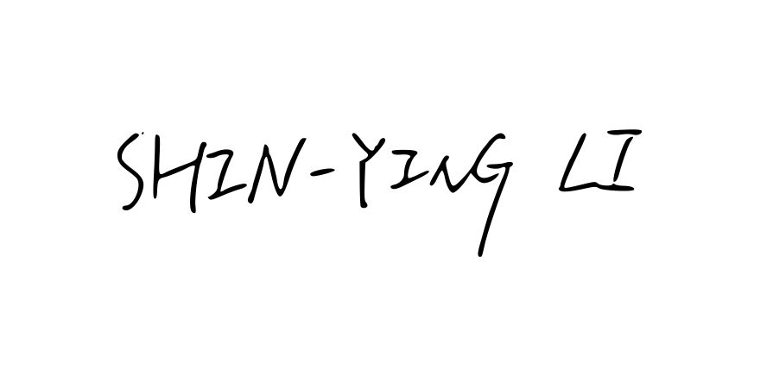

General coordinator, COSCUP 2019